**DAILY ONLINE ACTIVITIES SUMMARY**

|  |  |  |  |  |  |  |  |
| --- | --- | --- | --- | --- | --- | --- | --- |
| **Date:** | **28/06/2020** | | | | **Name:** | **VARSHA H SHETTY** | |
| **Sem & Sec** | **8th B** | | | | **USN:** | **4AL16CS117** | |
| **Online Test Summary** | | | | | | | |
| **Subject** | | **-** | | | | | |
| **Max. Marks** | | **-** | | **Score** | | **-** | |
| **Certification Course Summary** | | | | | | | |
| **Course** | Creating streaming video(continue) | | | | | | |
| **Certificate Provider** | | | **Aws** | **Duration** | | | **30 minutes** |
| **Coding Challenges** | | | | | | | |
| **Problem Statement:** | | | | | | | |
| **Status: COMPLETED** | | | | | | | |
| **Uploaded the report in Github** | | | | **YES** | | | |
| **If yes Repository name** | | | | **Varsha-Shetty** | | | |
| **Uploaded the report in slack** | | | | **YES** | | | |

Certification Course Details:

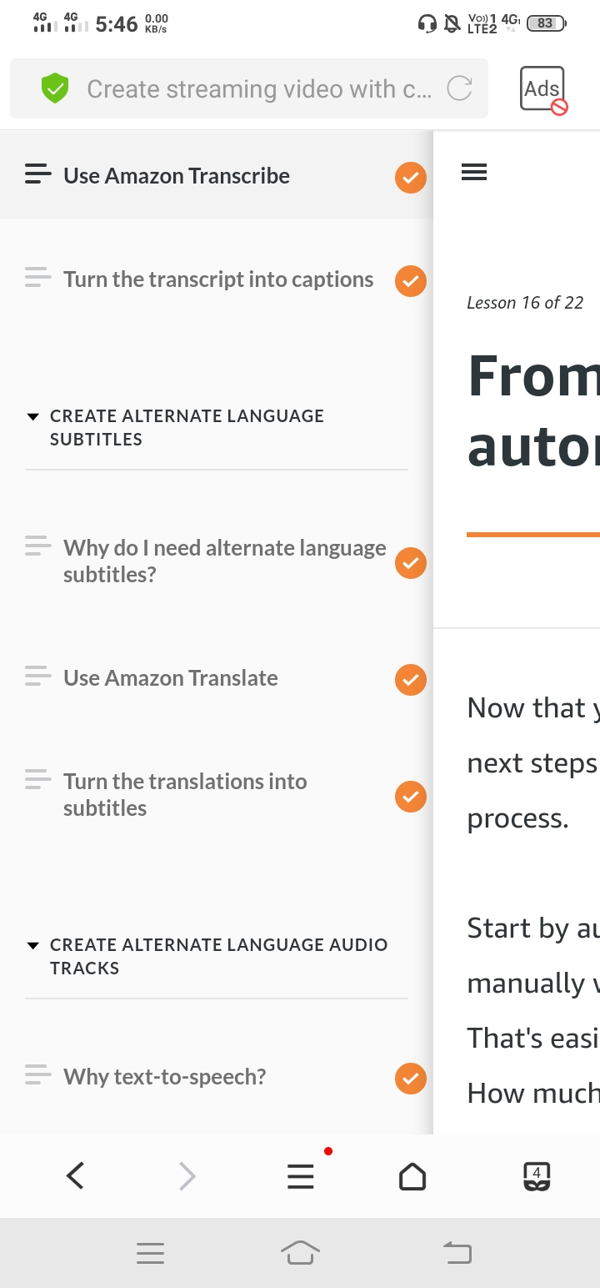

Coding Challenges Details

**Program no:1**

**package pk;**

**import java.util.Scanner;**

**public class StringOperators**

**{**

**public static void main(String args[])**

**{**

**int i;**

**String str;**

**int counter[] = new int[256];**

**Scanner in = new Scanner(System.in);**

**System.out.print("Enter a String : ");**

**str=in.nextLine();**

**for (i = 0; i < str.length(); i++) {**

**counter[(int) str.charAt(i)]++;**

**}**

**// Print Frequency of characters**

**for (i = 0; i < 256; i++) {**

**if (counter[i] != 0) {**

**System.out.println((char) i + ":-" + counter[i] + " times");**

**}**

**}**

**}**

**}**

**Program no:2**

**public class PingPong extends Thread {**

**static StringBuilder object = new StringBuilder("");**

**public static void main(String[] args) throws InterruptedException {**

**Thread t1 = new PingPong();**

**Thread t2 = new PingPong();**

**t1.setName("\nping");**

**t2.setName(" pong");**

**t1.start();**

**t2.start();**

**}**

**@override**

**public void run() {**

**working();**

**}**

**void working() {**

**while (true) {**

**synchronized (object) {**

**try {**

**System.out.print(Thread.currentThread().getName());**

**object.notify();**

**object.wait();**

**} catch (InterruptedException e) {**

**e.printStackTrace();**

**}**

**}**

**}**

**}**

**}**